 | CHILDREN PRIVACY POLICY  Park View Group Practice
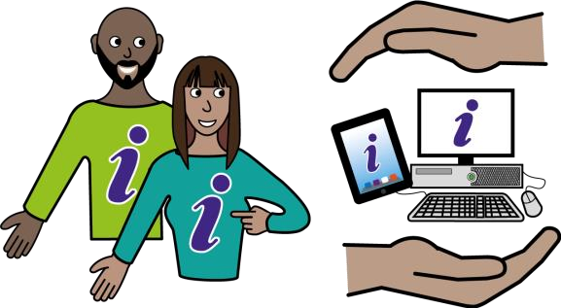 |  | We help people with their health and social care.  We decide how your personal data is used to help you.
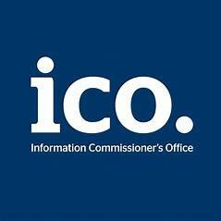 |  | We are registered with the Information Commissioner’s Office (ICO).  This means we can use information about the people we work with under the UK Data Protection Act 2018.  Our registration number is  Z6264723

What is personal data?
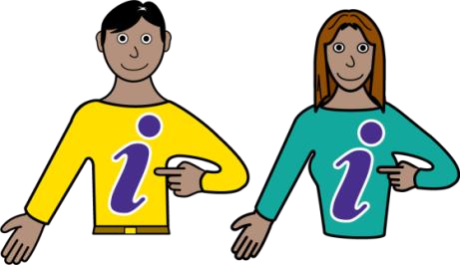 | Personal Information is information about you or other people

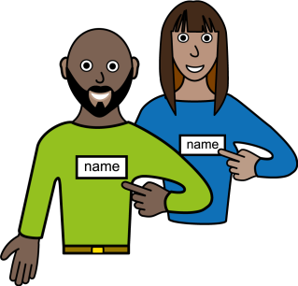  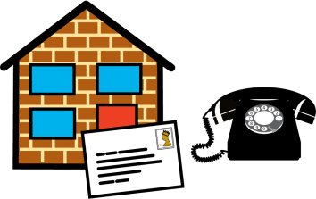  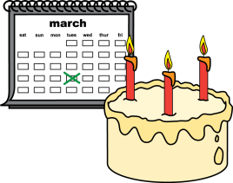  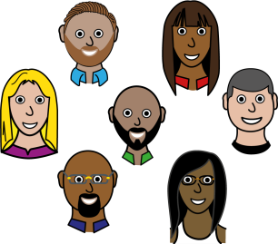  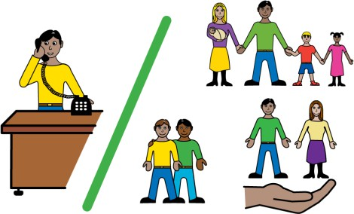 | Your name  Your address  Your telephone number  Your date of birth  Your ethnicity  Contact details for your family and carers

    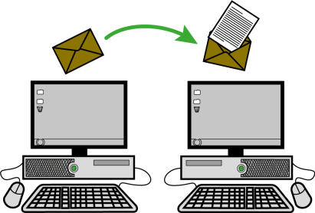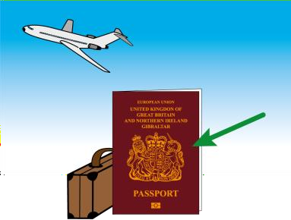  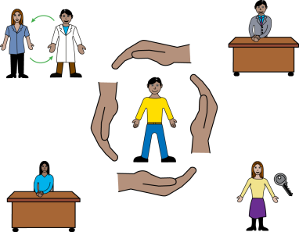 | If you are married  Your job  Your religion  Your email address  Where you were born  If you are using the NHS as an overseas visitor  What name you want to be called  Information about your health  If you have a protection order that affects your health, wellbeing and human rights (safeguarding status)

Why do we collect personal information about you?
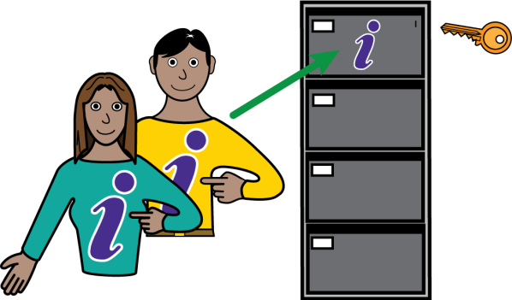 | We need to keep information about your health, treatment and care.
 | This is so we can give you good treatment and care.

What do we use your personal information for?
 | We won’t tell people your name unless we really have to.
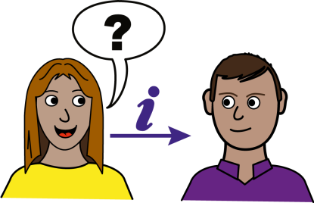 | We give your information to other people who are treating you.
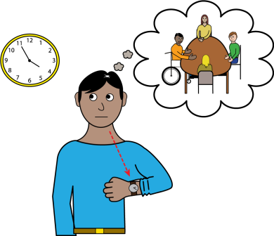 | To remind you about your appointments

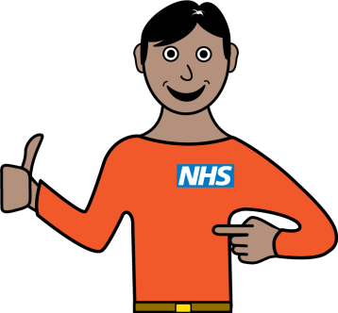 | To review our service to make it better

 | To share your information with the people who are paying for your care. These people are called commissioners.
 | To send reports to organisations such as the Department of Health
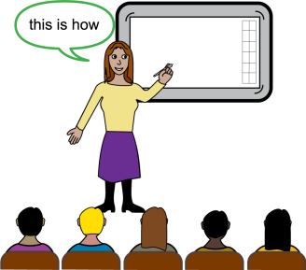 | To train healthcare staff
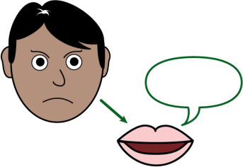 | If there is a complaint
 | If the law says we need to report something that has happened.

Who do we share information with and why?
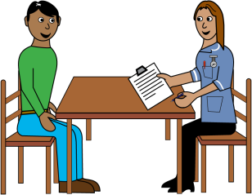 | We use it to make sure all the people involved in your care know what treatment you are getting.
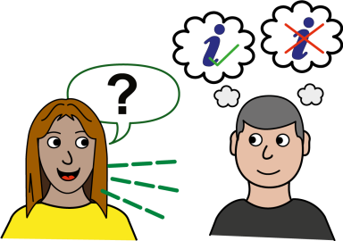 | We need to tell you how personal information will be used. We need to have a legal reason for using your information without asking you first.
 | We might need to give your information to other organisations.
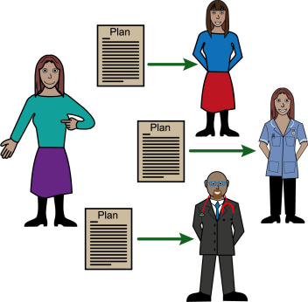 | We might share personal information with other NHS Organisations to help them give you healthcare.  This would be NHS England, Public Health England and other NHS Trusts, General Practitioners (GPs), Ambulance Services, Primary Care Agencies. This may also include those other organisations that help the NHS to look after your health.
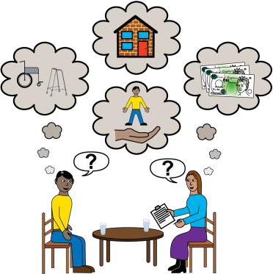 | We might share personal information with organisations like Social Services or private care homes to help them give you support.

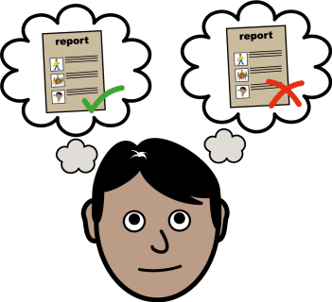 | Sometimes special permission will be given to use information that uses your name without your consent. This may be for medical research or checking quality of care. This permission is given by the Secretary of State for Health on advice from the National Information Governance Board for Health and Social Care under strict conditions.
 | Sometimes, we might need to share your information because it is the law. We will tell you when we do this.
 | To find out if fraud is happening.
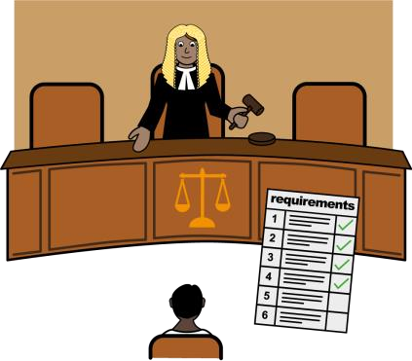 | If there is a court order.
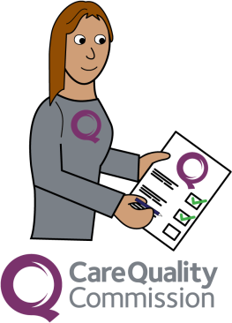 | If the Care Quality Commission need it for an inspection.

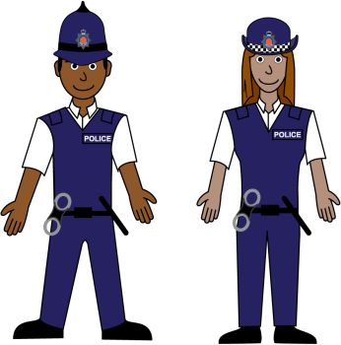 | If the Police need to investigate a crime.

Where do we get information about you?
 | From you
 | From your previous doctor (if you have one)
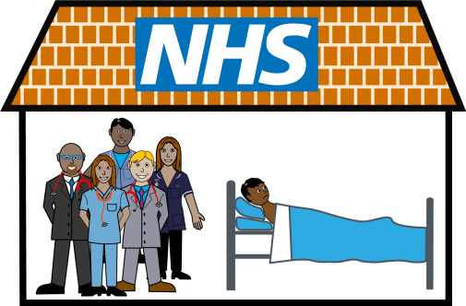 | From hospital

How do we keep information about you?
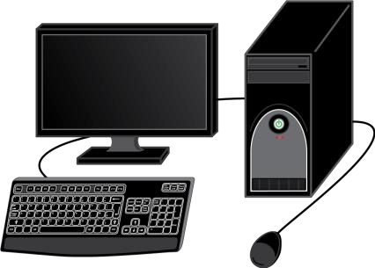 | We keep your information on paper and in a file.  We also keep your information in an electronic patient record system, on the computer.  The NHS Records Management Code of Practice for Health and Social Care 2016 and National Archives Requirements tells us to do this
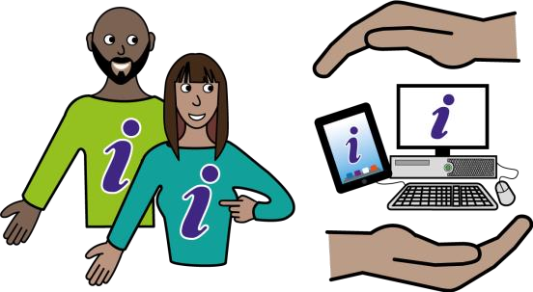 | The law tells us how to keep your information. These laws include the Data Protection Act 2018, the GDPR 2016, and the Common Law Duty of Confidentiality.
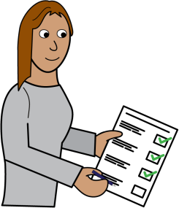 | We keep information about you for as long as we need to do make your health better
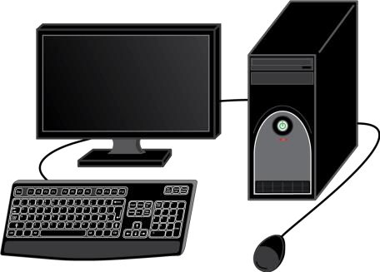 | You can read more about this online using this link (NHS Record Management code of practice): https://www.nhsx.nhs.uk/information- governance/guidance/records-management- code/records-management-code-of-practice-  2021/

We have to:
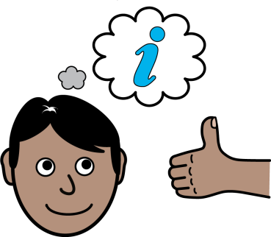 | Keep your records up to date, complete, and accurate, about the care we give you.
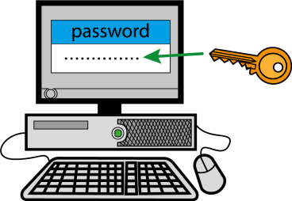 | Keep records about you confidential and secure.  We will make sure we keep your information safe, using computer passwords for electronic information, and locks for paper information.
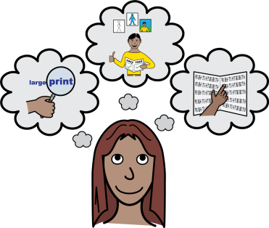 | Give you information in a way you can understand.

What are your rights?
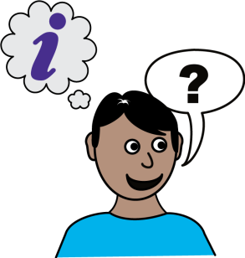 | You can ask to see the information we have about you
 | You can ask us to change any information that is wrong
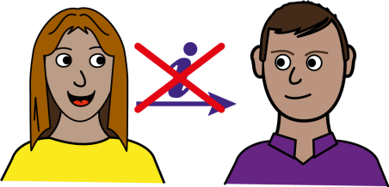 | You can tell us not to share your personal information (unless we need to because of the law)

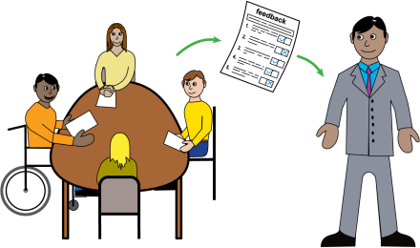 | You can ask us to give the records we have about you to another organisation.
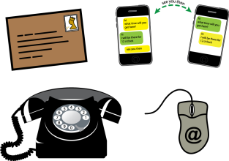 | For more information you can contact the Practice Manager or Data Protection officer: Ruth Quinn, nhsgm.gmgpdpo@nhs.net
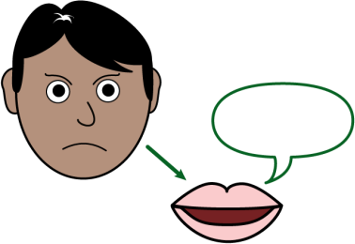 | If you are not happy with how we use your personal information you can contact the Information Commissioner’s Office. https://ico.org.uk .  Information Commissioner’s Office, Wycliffe House, Water Lane, Wilmslow, Cheshire, SK9 5AF  Tel: 0303 123 1113 (local rate) or  01625 545 745 if you prefer to use a national rate number  Fax: 01625 524 510  Email: casework@ico.org.uk

